Statement of Work

Grainger plc
LeadPro Replacement

Version 1.0
November 14, 2024

Contents
1 Statement of Work 3
1.1 Overview 3
1.2 Objectives 3
1.3 Delivery Approach 5
1.4 Responsibilities 6
1.5 Availability 6
1.6 References 7
2 Project Risks, Assumptions & Exclusions 8
2.1 Risks 8
2.2 Assumptions 8
2.3 Exclusions 9
3 Cost and Timelines 10
4 Acceptance 12

Statement of Work

Overview
Grainger is looking to purchase a subscription to Form Assembly (https://www.formassembly.com/) to allow data to be collected securely from webforms and saved in Salesforce. There are numerous use cases for this functionality, but Grainger would like to first use Form Assembly to replace the functionality provided by LeadPro (https://www.lead.pro/).
Currently Grainger use Rightmove (https://www.rightmove.co.uk/) to advertise available units and allow prospective tenants to submit enquiries related to these units. These enquiries are first routed to LeadPro for further enrichment of the prospects’ details and requirements. Once this has been completed, LeadPro creates a Lead record in the Grainger Salesforce org where it is assigned to a lettings agent to be progressed.
In order to replace LeadPro in the above process, Open Box is proposing to configure Form Assembly and Salesforce to replicate the current functionality as closely as possible, but without using LeadPro at all. This would allow Grainger to end their LeadPro subscription.

Objectives
The objectives of this project are to:
- Conduct sufficient upfront analysis in order for Open Box to be in a position to commence development.
  - Document the solution requirements and outcomes to be delivered in an initial, prioritized project backlog.
  - Write user stories, with detailed acceptance criteria, for the features that are anticipated to be addressed first. Acceptance criteria will be reviewed and agreed with Grainger.
- Refactor the current state (shown in Figure 1 below) so that Form Assembly and Salesforce provide the same functionality without requiring LeadPro.
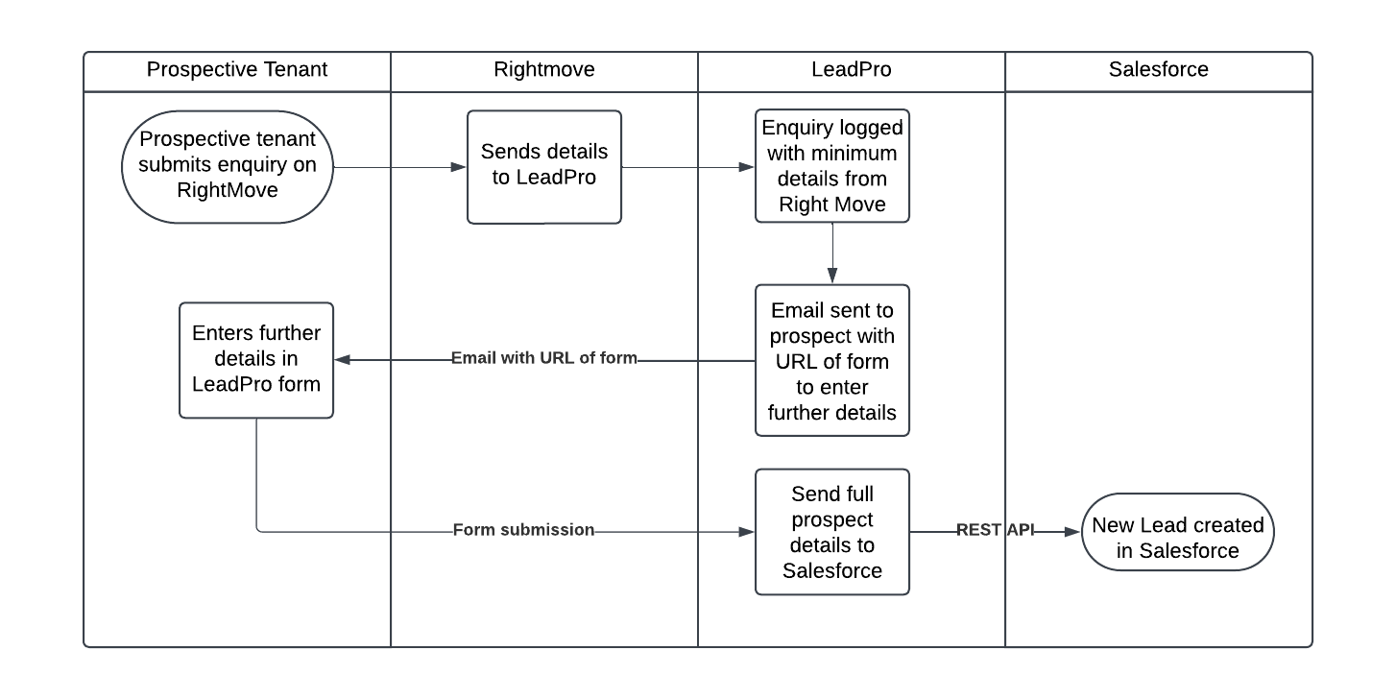
Figure 1 : Current State Functionality
- Implement a future state as shown in Figure 2 below:
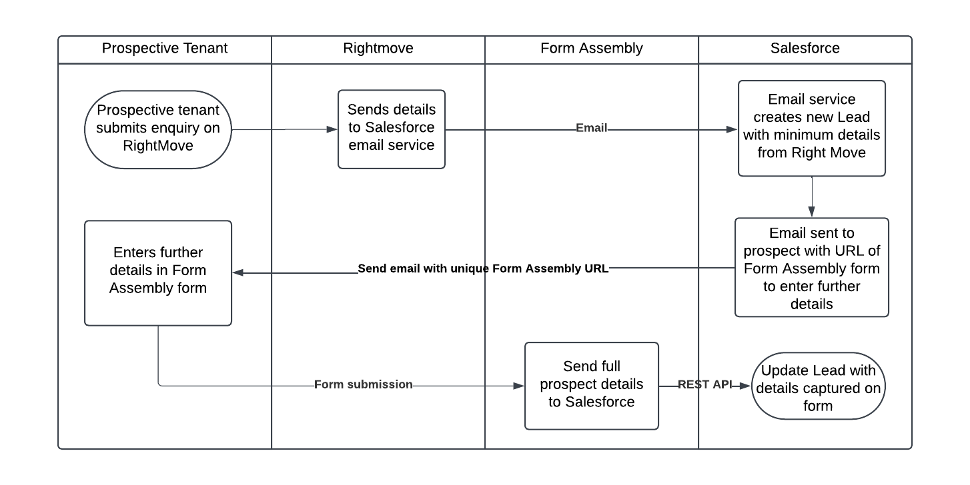
Figure 2 : Proposed Future State
- This will be done by making the following changes
  - Rightmove will send prospective tenant details directly to a Salesforce email service (as was earlier configured before LeadPro was implemented)
  - A custom email service implemented on Salesforce will process the above email to create a new Lead record (as was earlier configured before LeadPro was implemented). The new Lead will be assigned to a “holding queue” while it waits for enriched prospect data to be captured.
  - On creation of the new Lead record, an automated email will be sent by Salesforce to the prospective tenant with the URL of a Form Assembly form. The Lead Id will be passed as a secure URL parameter to uniquely link the prospects’ form to the corresponding Lead record in Salesforce.
  - The Form Assembly form above will present the prospect with a questionnaire to capture the same details as are currently captured by the LeadPro questionnaire.
  - When the prospect submits the Form Assembly form, the data captured in the form will be securely sent to Salesforce to update the corresponding Lead record.
  - The updated Lead will be assigned to a “lettings queue” where a lettings agent will follow up and progress the Lead.
  - If a prospect doesn’t submit the form to provide further details, up to 3 reminder emails will be sent from Salesforce on each subsequent day.

Delivery Approach
Due to a relatively well defined and small scope, the delivery approach will be based on the Kanban agile framework where features will be analysed, developed, tested and delivered continuously throughout the project.
A backlog will be maintained to track outcomes to be delivered and indicate priority of these outcomes relative to each other. The backlog will be a living artifact that will evolve as Open Box and Grainger collaborate. Grainger stakeholders will have access to the backlog which will serve as the single source of truth with regards to scope.
Grainger representatives will be required to participate in backlog refinement, demos and stand up ceremonies.

UAT
Grainger will be responsible for testing the functionality delivered and ensuring that the solution is performing as expected during the UAT period.
Issues raised will be classified as bugs or enhancements. Bugs will be fixed during the UAT period. Any other enhancements or new requirements will be added to the backlog for future development or addressed by extending the project timelines (by mutual agreement between Grainger and Open Box).

Support
Open Box will provide hypercare support for 10 working days immediately following the production deployment.

Responsibilities
- Open Box will be responsible for:
  - Providing the services described in the project Objectives.
  - Delivering a progress report to Grainger on a regular basis that will include:
    - General status update & project health
    - Project risks
    - Milestones and timelines
    - Any significant changes to project scope, cost, or timeline forecasts.
- Grainger will be responsible for:
  - Making key personnel and stakeholders available throughout the project lifecycle, including participation in the activities detailed in the Delivery Approach.
  - Ensuring there are no other projects planned or in operation that may hinder this project.

Availability
- Open Box resources will be contactable and available for meetings via conference calls/video conferences:
- Monday to Friday 9am – 6pm South African time (GMT +02:00) which currently corresponds to 7am – 4pm (GMT), excluding public holidays.
- A defined escalation path will be provided to the agreed project manager should urgent assistance be required outside of these times.
- All work will be completed by Open Box offsite.
  - It is not expected that the project will require Open Box resources on-site. Where onsite personnel are required, all reasonable expenses for travel and subsistence shall be reimbursed by Grainger. Open Box shall not bill any mark-up or administration fee for any such expenses. Approval for expenses shall be obtained from Grainger prior to being incurred.

References
- Grainger, Open Box meeting: Form Assembly SOW (Wednesday, 30 October 2024)

Project Risks, Assumptions & Exclusions

Risks
- A cutover strategy may be required to ensure LeadPro remains active for a few days/weeks after the go-live of this solution to ensure that active LeadPro forms that may have been sent to prospective tenants will still capture submitted data.
- Given this is a customer-facing process, comprehensive UAT testing should be done by Grainger.

Assumptions
The following assumptions have been made; incorrect assumptions may affect cost and timelines.
- Grainger will purchase a Form Assembly subscription that includes a Salesforce connector and a dedicated user for use by Open Box.
- Form Assembly forms will be published on Form Assembly infrastructure using a graingerplc.co.uk subdomain.
- Email templates for automated emails sent to prospects will be provided by Grainger.
- Forms created on Form Assembly will be done using the Form Assembly designer functionality and styled as closely as possible to match Grainger brand guidelines within the constraints imposed by the Form Assembly designer. Advanced styling and design would need to be covered by Grainger or another 3rd party.
- Rightmove will need to make changes on their side so that Lead details are sent to Salesforce via email instead of being sent to LeadPro

Exclusions
The following is not included in the cost or scope of this project:
- If it is required to publish Form Assembly forms on the graingerplc.co.uk website, the effort required from Code to do this is out of scope and is not included in this estimate.
- If any advanced styling and/or design of Form Assembly forms is required, the effort required from a specialist designer is out of scope and is not included in this estimate.
- Form Assembly subscription costs.
- Salesforce costs, license fees, subscriptions, or services.
- Hardware and infrastructure.
- Solution documentation, other than user stories.
- End-user training, change management or new / updated training materials.

Cost and Timelines
Open Box will provide an agile delivery team to develop, test and deploy the solution on a Time & Materials (T&M) basis at a rate of £120/hour.
The team will be staffed to include the following skillsets as required:
- Salesforce Technical Architect
- Business Analyst
- Developers
- Quality Assurer
- Project Manager

The estimated effort and costs per phase are shown in the table below:
Phase | Hours | Lower Bound | Upper Bound
Analysis | 8-10 | £ 960 | £ 1,200
Build | 40 - 48 | £ 4,800 | £ 5,760
Project Management | 4-5 | £ 480 | £ 600
UAT | 8-10 | £ 960 | £ 1,200
Production deployment and post go-live support | 8-10 | £ 960 | £ 1,200
Total | 68 - 83 | £ 8,160 | £ 9,960

The anticipated timeline is shown below, start date
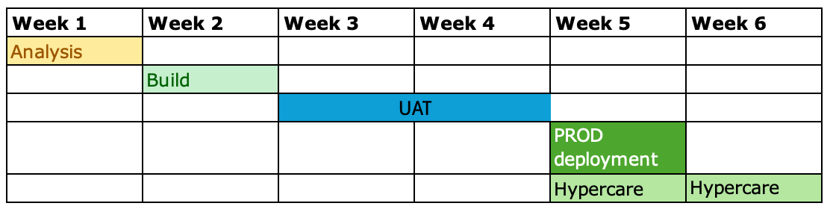
The total duration of the project is therefore expected to be 4 weeks as well as an additional 2 weeks of hypercare support.
The total cost is therefore estimated to be between £8 160 and £9 960.
These costs and timelines are forecasts. Any expected variations will be communicated via the weekly project status reports provided by Open Box.
All amounts are quoted in GBP and exclude VAT, if applicable.
The project cost will be billed monthly, in arrears, up until the completion of the final project phase. Cost will be reported to Grainger on a in the weekly project management report during the course of the project. The cost will not exceed the upper limit of £9 960 without prior consultation.
This quotation is valid for 30 days.

Acceptance
The parties hereto, each acting under due and proper authority, have executed this Agreement as of the day, month and year first written below.

For and on behalf of Open Box Software For and on behalf of Grainger

Signature: _____________________ Signature: _____________________
Name: Sam Duncan Name:
Position: Salesforce Director Position:
Date: _____________________ Date: _____________________

